


Personal Learning Portfolio

Course： English Academic Writing Teacher： Zhang Mei
Class： 001 Major： CS
Name： Student Number：
Class Time： 2024.02-2024.06
Grade：

Self | Teaching Assistant | Teacher
9

Comments：

Teacher (Signature)
Contents

Starting to Learn English Academic Writing
- My learning
- In class
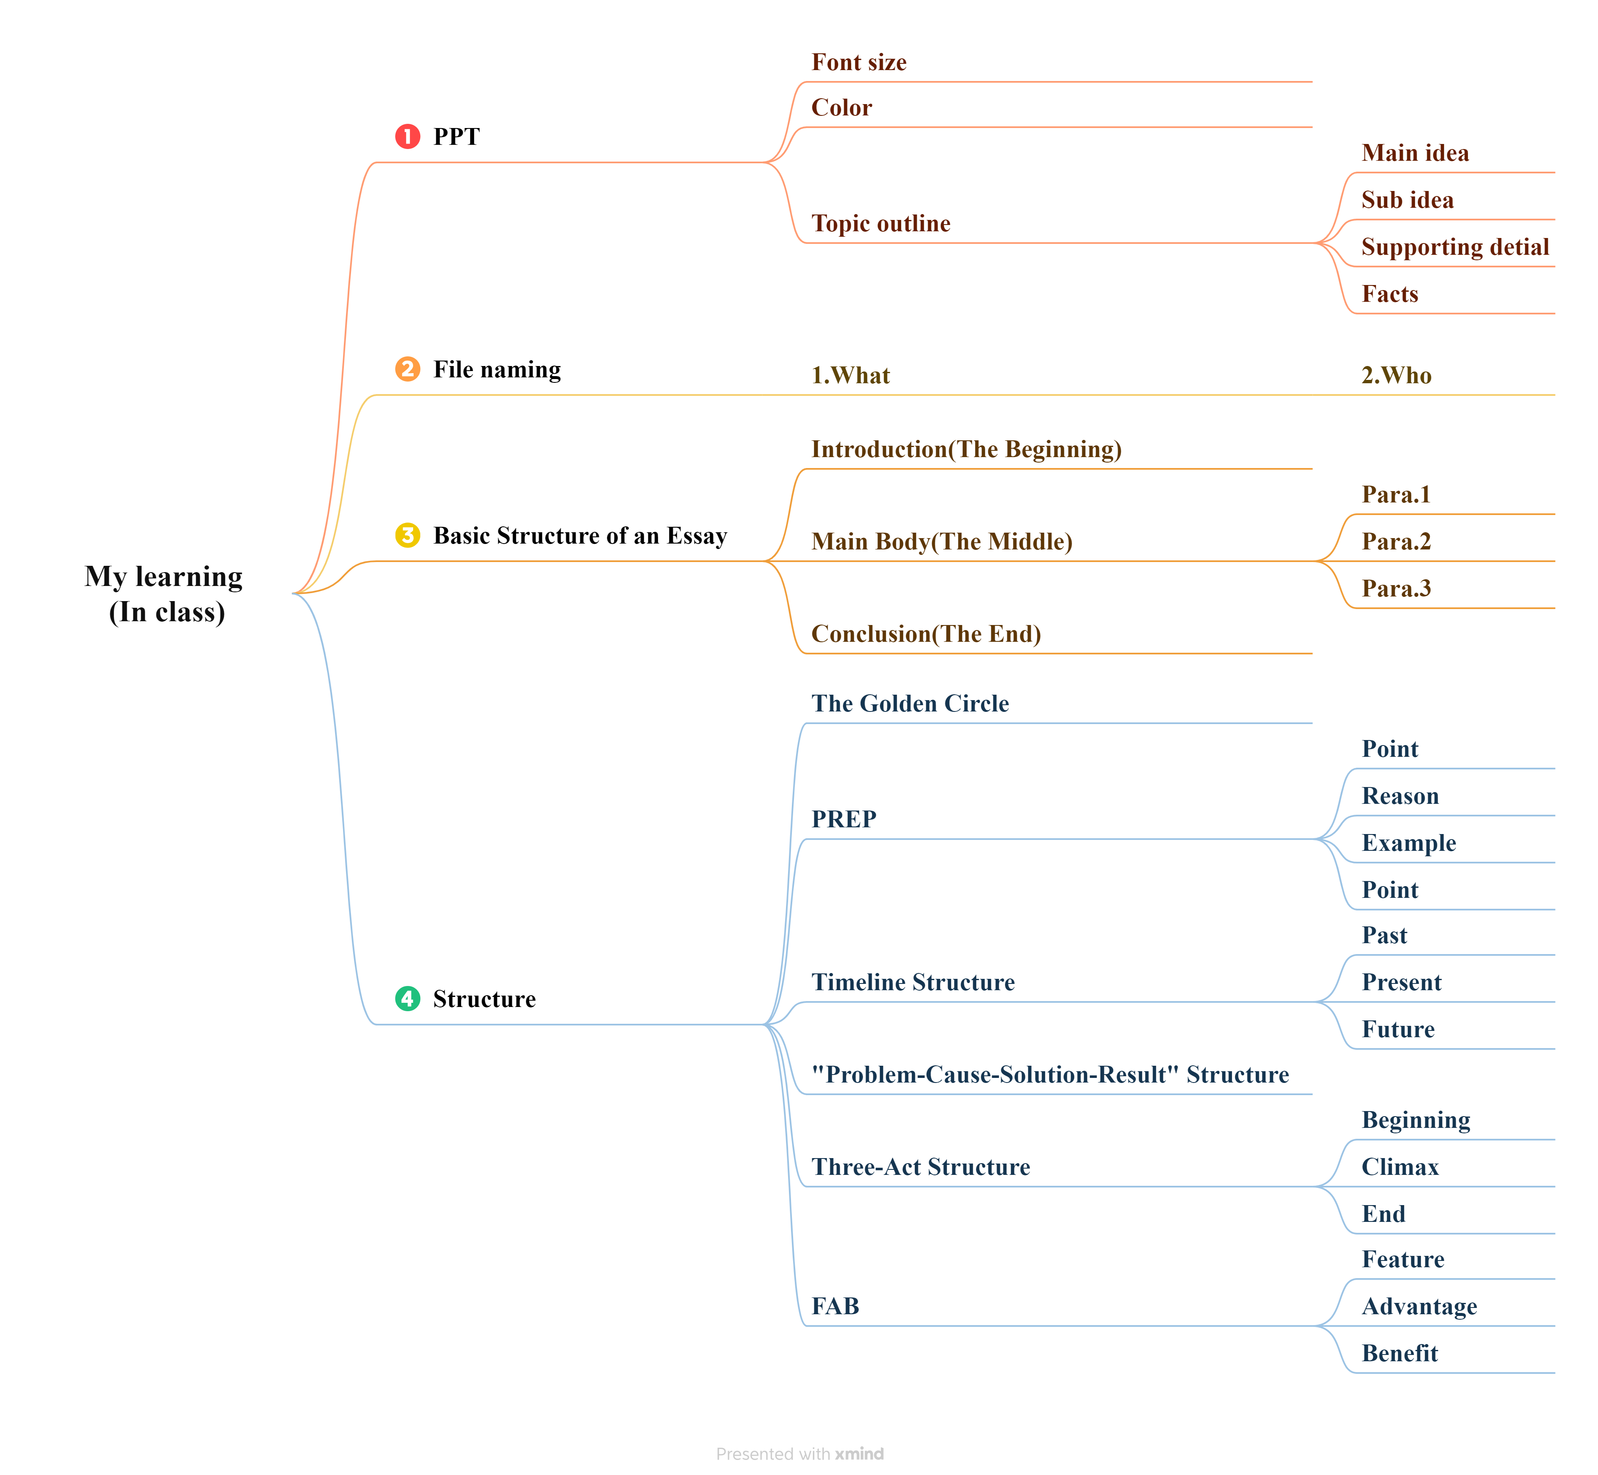

- Out of Class
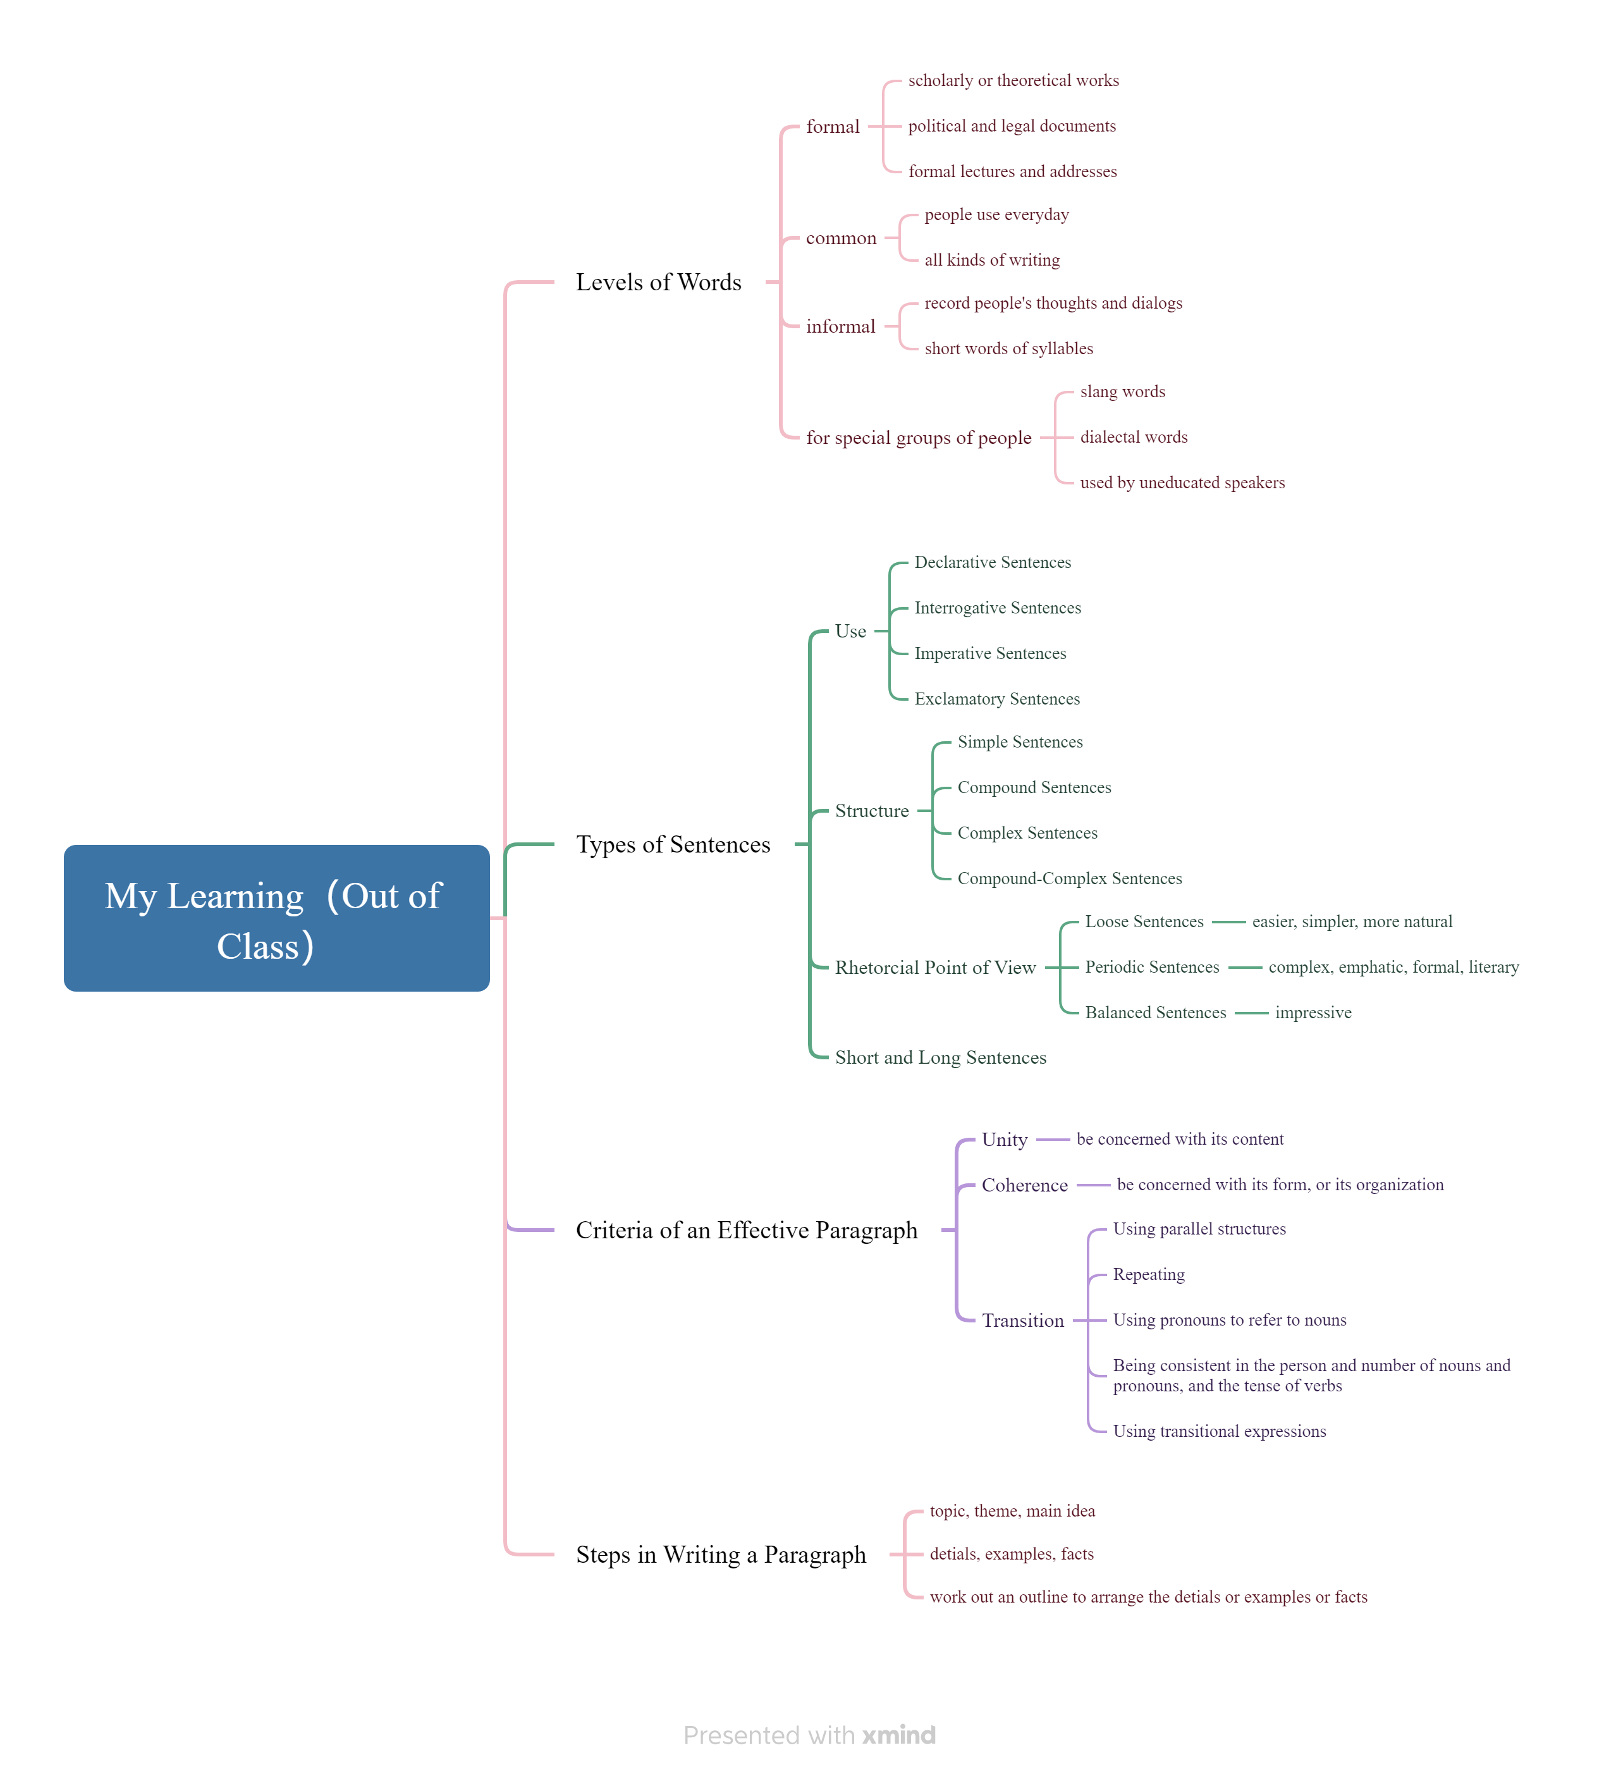
- Learning outcomes
1）In class
1) During oral presentations, it's crucial to actively engage with the audience and effectively utilize visual aids like PowerPoint slides.(Main idea, Sub idea, Supporting detail, Facts)
2) When delivering an oral presentation, it's beneficial to consider the organization and framework of the speech, such as employing models like the Golden Circle , the PREP method or the FAB method and so on.
3) For naming a file, it's important to first indicate what it is, followed by specifying who it belongs to.
2）Out of Class
1) From extracurricular learning, I've learned that words can be categorized into three levels: formal, informal, and common. In the future, I'll be able to use words correctly according to different occasions and needs.
2) A paragraph should begin by identifying its topic. Following this, it should be expanded with details and examples to develop the body of the text. Finally, work out an outline to arrange the details or examples or facts.
3) There are many types of sentences, which can be classified based on their Use, Structure, Rhetorical Point of View, as well as their length, including both short and long sentences. Understanding these classifications can greatly assist me in comprehending the types of sentences in the future.
4) Considering Unity, Coherence, and Transition in writing a paragraph provides clear direction for future writing endeavors.
- My behavior and attitude
1）Out of Class
1.1 Autonomous learning (Online + Offline)
1.1.1 Online (CET-6 online course)
1.1.2 Offline (memorize vocabulary and listen to CET-6 listening exercises)
1.2 Homework
I completed my English assignment promptly with a diligent and meticulous attitude, ensuring it was not procrastinated until the deadline.
1.3 Cooperative learning（discuss team name）
2）In Class
2.1 Individual performance (Take notes promptly and attentively focus during class).
2.3 Cooperation (Actively participate in classroom discussions)
4．Improvement
This week's study has provided me with an initial understanding of the course on English academic writing. Moreover, during class, I acquired some valuable techniques for future presentations. Overall, this week's English learning experience has been greatly beneficial to me.

